**6.1 DNA Structure\***

* Macromolecule that stores genetic information in all living organisms

Nucleosides and Nucleotides

* Nucleoside = five-carbon sugar bonded to a nitrogenous base
* Nucleotide = nucleoside + 1 / 2/ 3 phosphate groups
  + Contain deoxyribose in DNA
  + Contain ribose in RNA

Sugar-Phosphate Backbone

* Phosphates carry a negative charge, thus DNA and RNA strands have an overall negative charge
* DNA strands run antiparallel to one another, wound into a double helix
* Enzymes that replicate and transcribe DNA only work in the **5’ to 3’ direction** (recall free 3’-OH group)

Purines and Pyrimidines

* Purines (A and G) always pair with pyrimidines (C, U, and T)
* A pairs with T via 2 hydrogen bonds; C pairs with G via 3 hydrogen bonds
* RNA does not contain T, but contains U instead → A pairs with U via 2 hydrogen bonds

Watson-Crick Model

* % A = % T
* % G = % C

Denaturation and Reannealing

* DNA strands can be pulled apart (denatured) by heat, alkaline pH, chemicals eg. formaldehyde, and urea
* DNA can also be brought back together (reannealed) by removing these conditions

**6.2 Eukaryotic Chromosome Organization**

Histones

* DNA is wound around histone proteins (H2A, H2B, H3 and H4) to form nucleosomes, which may be stabilized by another histone protein (H1)
* DNA + associated histones = chromatin in the nucleus

Heterochromatin and Euchromatin

* Heterochromatin = **dense, transcriptionally silent DNA** that appears dark under light microscopy
* Euchromatin = **less dense, transcriptionally active DNA** that appears light under light microscopy

Telomeres and Centromeres

* Telomeres = end of chromosomes
  + Contain high G-C content to prevent unravelling of the DNA
  + During replication, telomeres are slightly shortened, although this can be (partially) reversed by the enzyme telomerase
* Centromeres are located in the middle of chromosomes → hold sister chromatids together until they are separated during anaphase in mitosis
  + Contain high G-C content to maintain a strong bond between chromatids

**6.3 DNA Replication**

|  |  |  |
| --- | --- | --- |
| **Step in Replication** | **Prokaryotic Cells** | **Eukaryotic Cells (Nuclei)** |
| **Origin of Replication** | One per chromosome | Multiple per chromosome |
| **Unwinding of DNA double helix** | Helicase | Helicase |
| **Stabilization of unwound template strands** | Single-stranded DNA-binding protein | Single-stranded DNA-binding protein |
| **Synthesis of RNA primers** | Primase | Primase |
| **Synthesis of DNA primers** | DNA polymerase III | DNA polymerases α, δ, and ε |
| **Removal of RNA primers** | DNA polymerase I (5’ → 3’ exonuclease) | RNase H (5’ → 3’ exonuclease) |
| **Replacement of RNA with DNA** | DNA polymerase I | DNA polymerase δ |
| **Joining of Okazaki fragments** | DNA ligase | DNA ligase |
| **Removal of positive supercoils ahead of advancing replication forks** | DNA topoisomerases (DNA gyrase) | DNA topoisomerases |
| **Synthesis of telomeres** | Not applicable | Telomerase |

**6.4 DNA Repair**

Oncogenes and Tumor Suppressor Genes

* Oncogenes = accelerators
  + Develop from mutations of proto-oncogenes, and promote cell cycling
  + May lead to cancer i.e. unchecked cell proliferation with the ability to spread by local invasion or metastasize
* Tumor suppressor genes = brakes
  + Code for proteins that reduce cell cycling or promote DNA repair
  + Mutations of TSG can also lead to cancer

Proofreading and Mismatch Repair

* Proofreading
  + Done by DNA polymerase during replication → incorrectly matched bases will be excised
  + The daughter strand is identified by its lack of methylation and corrected accordingly
* Mismatch repairs
  + Occur during the G2 phase of the cell cycle
  + Using the genes *MSH2* and *MLH1*

Nucleotide and Base Excision Repair

* Nucleotide excision repair
  + Fixes **helix-deforming lesions** of DNA e.g. thymine dimers caused by UV rays
  + Via a cut-and-patch process that requires an excision endonuclease
* Base excision repair
  + Fixes **non-deforming lesions** of the DNA e.g. cytosine deamination caused by thermal energy absorption
  + By removing the base, leaving an AP site → an AP endonuclease then removes the damaged sequence, which can be filled in with the correct bases

**6.5 Recombinant DNA and Biotechnology\***

* Recombinant DNA = DNA composed of nucleotides from two different sources

DNA Cloning and Restriction Enzymes

* Restriction enzyme (RE) cuts both the plasmid and the fragment → left with sticky ends
* Bind the fragment to the plasmid
* Introduce the recombinant DNA into a bacterial cell for replication → generate many copies of the fragment of interest

DNA Libraries and cDNA

* DNA libraries = large collections of known DNA sequences

1. Genomic libraries
   1. Contain large fragments of DNA (**coding + noncoding** regions of the genome)
   2. Cannot be used to make recombinant proteins or for gene therapy
2. cDNA libraries (expression libraries)
   1. Contain smaller fragments of DNA, and can only include the **exons** of the genes expressed by the sample tissue
   2. Can be used to make recombinant proteins or for gene therapy

Hybridization

* Joining of complementary base pair sequences

1. Polymerase Chain Reaction (PCR)
   1. Automated process by which millions of copies of a DNA sequence can be created from a very small sample by hybridization
2. Southern blotting
   1. Used to detect the presence and quantity of various DNA strands in a sample
   2. After electrophoresis, the sample is transferred to a membrane that can be probed with ssDNA molecules to look for a sequence of interest

DNA Sequencing

* Uses dideoxyribonucleotides, which terminate the DNA chain because they lack a 3’-OH group
* The resulting fragments can be separated by gel electrophoresis, and the sequence can be read directly from the gel

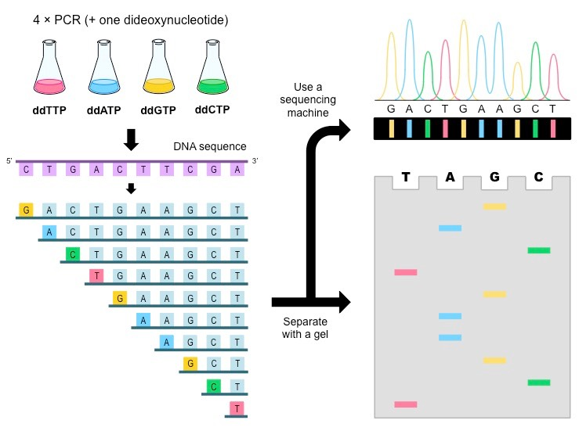

Applications of DNA Technology

1. Gene therapy
   1. A method of curing genetic deficiencies by introducing a **functional gene with a** **viral vector**
2. Transgenic mice
   1. Created by integrating a gene of interest into the **germline** or **embryonic stem cells** of a developing mouse
   2. Chimeras = organisms that contain cells from two different lineages (e.g. mice formed by integration of transgenic embryonic stem cells into a normal blastocyst)
   3. Can be mated to select for the transgene
3. Knockout mice
   1. Created by deleting a gene of interest

Safety and Ethics

1. Pathogenic resistance
2. Ethics of choosing individuals for specific traits